Systematic Review Process Based on PRISMA

1. Write a protocol which follows the PRISMA-P template. (structure on second page)
2. Rationale
3. Objectives (research questions, PIRD for DTA and SPICE for UX)
4. Eligibility criteria (specify study characteristics)
5. Information sources (which databases searched)
6. Search strategy (search queries)
7. Data management
8. Selection process (screening and full-text reading)
9. Data collection (how to extract the data)
10. Data items (what data to extract)
11. Outcomes and prioritisation
12. Risk of bias in individual studies
13. Data synthesis (type of analysis undertaken and how)
14. Run the searches
15. Screen title and abstract
16. Read full text
17. Complete PRISMA flow diagram
18. Data extraction
19. Meta-analysis for technical and thematic analysis for UX

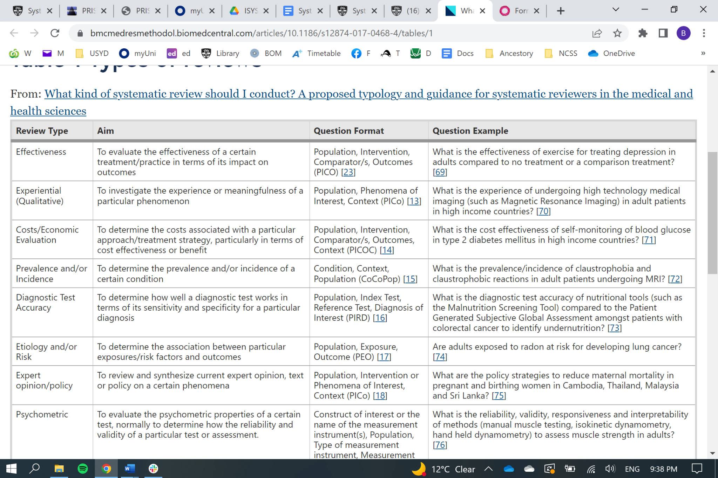

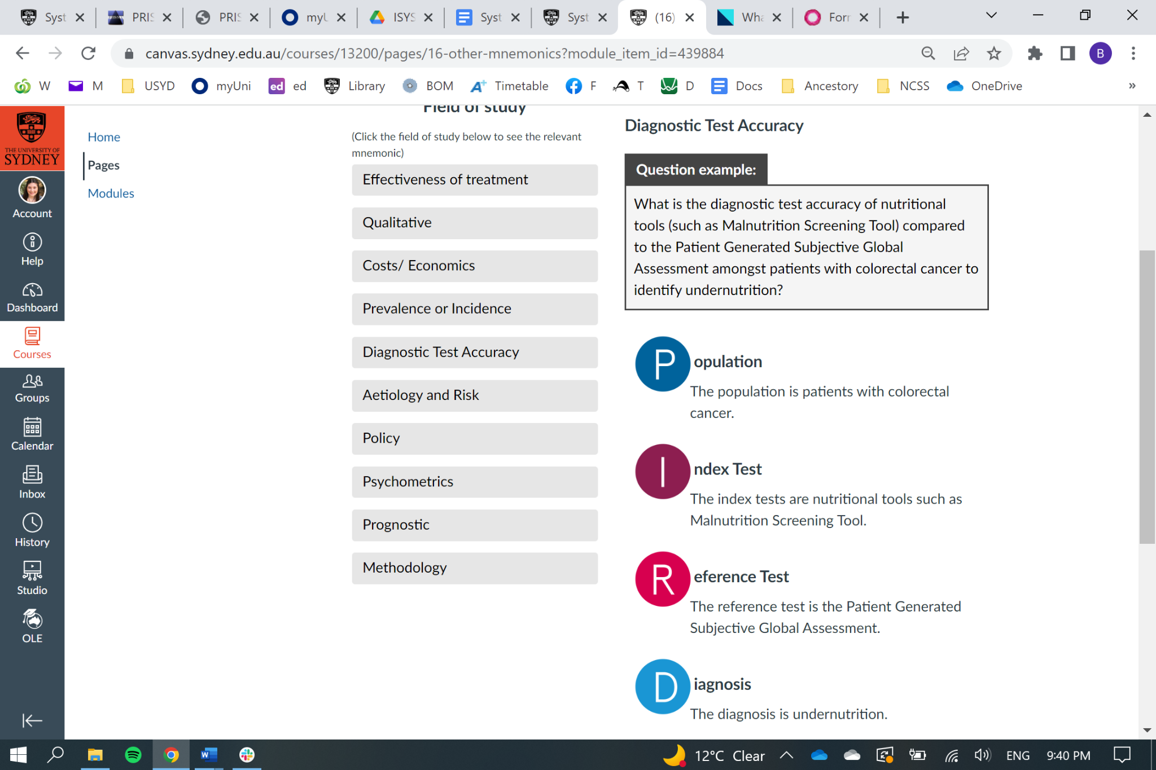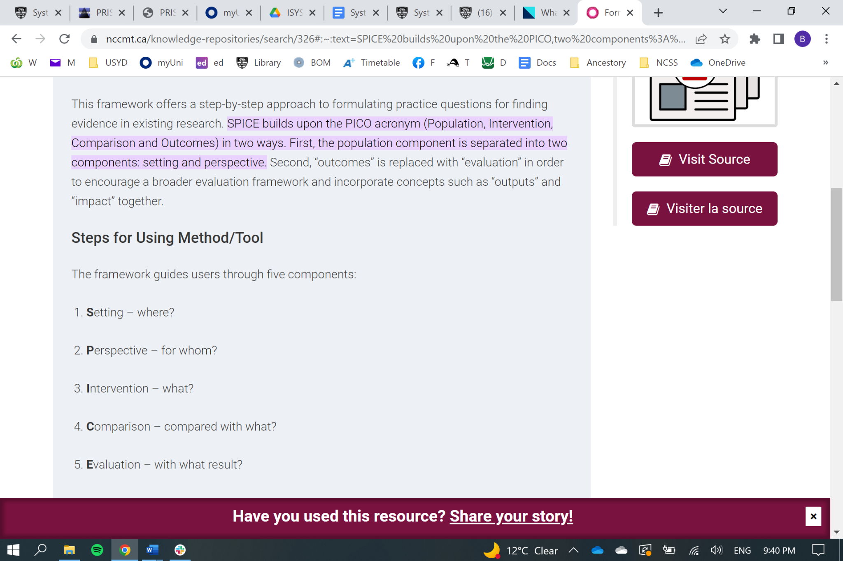

# Introduction

## Rationale

6 Describe the rationale for the review in the context of what is already known

## Objectives

7 Provide an explicit statement of the question(s) the review will address with reference to participants, interventions,

comparators, and outcomes (PICO)

# Methods

## Eligibility criteria

8 Specify the study characteristics (such as PICO, study design, setting, time frame) and report characteristics (such as years

considered, language, publication status) to be used as criteria for eligibility for the review

## Information sources

9 Describe all intended information sources (such as electronic databases, contact with study authors, trial registers or other

grey literature sources) with planned dates of coverage

## Search strategy

10 Present draft of search strategy to be used for at least one electronic database, including planned limits, such that it could be

repeated

## Study records

### Data management

11a Describe the mechanism(s) that will be used to manage records and data throughout the review

### Selection process

11b State the process that will be used for selecting studies (such as two independent reviewers) through each phase of the review (that is, screening, eligibility and inclusion in meta-analysis)

### Data collection process

11c Describe planned method of extracting data from reports (such as piloting forms, done independently, in duplicate), any processes for obtaining and confirming data from investigators

## Data items

12 List and define all variables for which data will be sought (such as PICO items, funding sources), any pre-planned data assumptions and simplifications

## Outcomes and prioritisation

13 List and define all outcomes for which data will be sought, including prioritisation of main and additional outcomes, with rationale

## Risk of bias in individual studies

14 Describe anticipated methods for assessing risk of bias of individual studies, including whether this will be done at the outcome or study level, or both; state how this information will be used in data synthesis

## Data synthesis

15a Describe criteria under which study data will be quantitatively synthesised

15b If data are appropriate for quantitative synthesis, describe planned summary measures, methods of handling data and methods of combining data from studies, including any planned exploration of consistency (such as I2 , Kendall’s τ)

15c Describe any proposed additional analyses (such as sensitivity or subgroup analyses, meta-regression)

15d If quantitative synthesis is not appropriate, describe the type of summary planned

## Meta-bias(es)

16 Specify any planned assessment of meta-bias(es) (such as publication bias across studies, selective reporting within studies)

## Confidence in cumulative evidence

17 Describe how the strength of the body of evidence will be assessed (such as GRADE)